INITIAL EXAMINATION FORM

Name: | Date:
Date of Birth: | Where did you hear about me?

Your Address: | Your Doctor/Doctor Surgery:
Telephone: | Mobile:
Email: | Occupation:
Marital Status: | Children:

Do you have any Blood Clotting Problems - Naturally or due to Medication?

Have you had any Lymph nodes removed - yes (and so where please)/no
If yes, please contact me on 07571 422 447 to discuss.

Do you have any conditions relating to your bones?

Do you have Cancer?

Do you have a Reduced Immune System:

If so, why please:
Are you Pregnant - Yes/No/Trying/Assisted:

Medication : | What dose and how for how long? | What is it for please:

Other therapies at present:

Under 16’s

If the treatment is for someone under the age of 16 please would you complete the following:

Name of the person requiring treatment:

Date of birth of the person requiring treatment:

Name/s of the parent/s, guardian/s granting permission:

Relationship to the patient:

Signature of the parent/s, guardian/s granting permission:

Date signed:

Data Protection - How the information you provide will be used.

General Data Protection Regulations - Any personal information such as name, postal address, telephone number, and email address given via this form/website will only be used to provide a requested service, kept for a minimum of seven years or in the case of minors until the patient reaches the age of twenty-five (this is to comply with our insurance requirements) and will not be disclosed to any other third party without your prior permission or unless we are required to do so by law.

Consent for email marketing/newsletter.

By signing this form you are confirming that you are consenting to Mark Shepherd holding and processing your personal data for the following purposes (please tick the boxes where you grant consent):-

I (please write your name) _______________________________consent to Mark Shepherd contacting me ☐ email using the following email address:____________________________________

To keep me informed about news, events, activities and special offers at my practice.

Please note you can unsubscribe from our e-newsletter and request that we stop sending you marketing materials at any time.

Signed |  | Date

Where you do not grant consent we will not be able to use your personal data for marketing purposes (so for example, we may not be able to let you know about open days or special offers). We will still be able to use your personal data for: yours or our legitimate interests in connection with the provision of health care services to you; or if necessary in compliance with a legal obligation which our practice/clinic is subject to. These lawful uses of your personal data not requiring your consent are set out in our Privacy Notice.

You can withdraw or change your consent at any time by Mark Shepherd, Manor Farm Barns, Manor Farm, Donnington. Please note that all processing of your personal data for marketing purposes will cease once you have withdrawn consent but this will not affect any personal data that has already been processed prior to this point. All other lawful processing of your personal data because: it is in yours or our legitimate interests in connection with the provision of health care services to you; or it is necessary in compliance with a legal obligation which our practice/clinic is subject to – may continue.

END OF CONSENT FORM

What are your main reasons for Treatment?

For each reason:
- How long have you had the problem?
- What makes it worse or better?
- When do you notice it?
- What do you feel caused it?
- What else have you tried to make it better and how did that help?
- What exactly does it makes difficult for you in your life?

How bad please? | Please rate the discomfort for all for each of these out of 10, where 10 is severe and 0 is OK. There is a diagram that may help you on the next page.

Please draw the location of points of pain or discomfort and, for all for each of these out of 10, where 10 is severe and 0 is OK please.

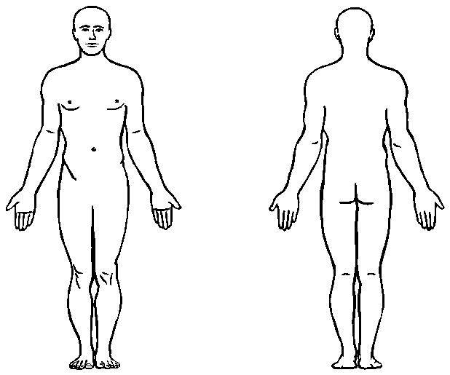

Is your Sleep | Good /Average /Poor  If not good what is happening for your?  Do you have nightmares?

Is your Digestion | Good/Average/Poor  If not good, what is happening for you?

Your bowel movements | How often do you go::  Is there any:  Pain  Blood  Mucous  Is the odour always strong?  Would you say your stools are:  Loose/OK/Hard

Urine | How often do you go?  Is it generally a good amount? Yes/No  Is the colour dark? Yes/No  Is it strong smelling? Yes/No  Is there any blood/pain /mucous? Yes/No  Do you ever lose any urine when you do not mean to? Yes/No  Can you hang on when you need? Yes/No

Do you find | Your sweating seems too much/about right/I barely sweat.  You particularly feel the heat or feel the cold?

Your menstrual cycle | How old were you when your began having periods?  How long is your monthly cycle? Eg 28 days  How many days is your actual cycle?  Does your cycle cause do any pain? If so where please?  Does your cycle affect how you feel in yourself?

Do you get? | Headaches Yes/No  Dizziness Yes/No  Numbness Yes/No  Mouth Ulcers Yes/No  Cold Sores Yes/No

Do you | Experience palpations, Yes/No  Have a good Memory, Yes/No  Suffer with Anxiety, Yes/No  Notice you are Easily Startled eg jump easily at loud noises? Yes/No

Do you | Catch Colds easily, Yes/No  Get Short of breath, Yes/No  Have Asthma, Yes/No  Get Hayfever Yes/No  Have Allergies Yes/No

Do you get | Dizzy if you stand up quickly Yes/No  Floaters across your vision Yes/No  Dry Eyes Yes/No  Hot and or sweaty at night Yes/No  Cramp Yes/No

Have you had any significant accidents and have you had any operations?

Were you healthy as a child?

What do you enjoy?

What exercise do you do?
Family History

Please let me know of any family medical problems ie known health problems of your grand- parents, parents, brothers and sisters.

Breakfast:  Lunch:  Dinner:  Snacks:  Drinks ie tea, coffee, water etc:  Alcohol:  Smoking:  Drugs: | What is your typical:

Thank you for your time in completing this and I look forward to seeing you soon.

If you have any questions, please feel free to call me on 07517 422 447.

Thank you.

